**BIG DATA ANALYSIS withIBM CLOUD DATABASES**

**Project Overview:**

1. **Project Title:** Provide a clear, concise title for the project.
2. **Project Objectives:** Define the main goals and objectives of the project, such as improving decision-making, optimizing operations, or gaining insights into customer behavior.
3. **Business Context:** Explain the business problem or opportunity that necessitates the use of big data analytics.
4. **Scope and Deliverables:** Clearly define what the project will deliver, including reports, dashboards, predictive models, or other outcomes.
5. **Stakeholders:** Identify the key stakeholders and their roles in the project.
6. **Constraints and Assumptions:** Document any limitations, such as data availability, budget, or time constraints, and make any assumptions explicit.
7. **Success Criteria:** Define how project success will be measured, such as improvements in key performance indicators (KPIs).

**Design Thinking Process:**

1. **Empathize:**
   * Understand the needs and pain points of end-users and stakeholders.
   * Gather insights through interviews, surveys, and data analysis.
2. **Define:**
   * Clearly articulate the problem statement based on the insights gained.
   * Prioritize and set specific objectives for the project.
3. **Ideate:**
   * Brainstorm potential solutions and approaches for addressing the defined problem.
   * Encourage creative thinking and diverse ideas.
4. **Prototype:**
   * Create initial data models, algorithms, or visualizations to test and refine ideas.
   * Develop proof-of-concept solutions to demonstrate feasibility.
5. **Test:**
   * Collect feedback from users and stakeholders on the prototypes.
   * Iterate on the designs based on feedback to refine the solution.

**Development Phases:**

1. **Data Collection and Preparation:**
   * Gather and clean the relevant data from various sources.
   * Ensure data quality and consistency.
   * Perform ETL (Extract, Transform, Load) processes.
2. **Data Analysis and Exploration:**
   * Explore the data to identify patterns, correlations, and potential insights.
   * Use statistical techniques and visualization tools.
3. **Modeling and Algorithm Selection:**
   * Choose appropriate machine learning or statistical models based on project goals.
   * Train and validate the models using the data.
4. **Development of Analytics Tools or Dashboards:**
   * Create data visualizations, dashboards, or reporting tools to communicate the results to stakeholders.
   * Ensure user-friendly interfaces for decision-makers.
5. **Testing and Validation:**
   * Test the analytics solution on a smaller scale or with historical data to validate its accuracy and effectiveness.
6. **Deployment and Integration:**
   * Deploy the analytics solution in the production environment.
   * Ensure integration with existing systems and processes.
7. **Monitoring and Maintenance:**
   * Continuously monitor the performance of the analytics solution.
   * Make necessary updates and improvements based on changing requirements or data patterns.
8. **Documentation and Knowledge Transfer:**
   * Document the project processes, models, and findings.
   * Transfer knowledge to the relevant teams for ongoing support and maintenance.
9. **Evaluation and Reporting:**
   * Assess the project's success based on the defined success criteria.
   * Provide regular reports to stakeholders.
10. **Feedback and Iteration:**
    * Gather feedback from users and stakeholders for further improvement and iteration of the solution.

**Platform Layout and Features:**

1. **User Interface (UI):**
   * Intuitive and user-friendly dashboard.
   * Customizable widgets and visualizations.
   * Support for multiple user roles and permissions.
2. **Data Integration:**
   * Ability to ingest data from various sources (databases, APIs, files, streaming data).
   * Real-time data integration capabilities.
   * Data transformation and cleansing features.
3. **Data Storage:**
   * Scalable and high-performance storage for raw and processed data.
   * Support for both structured and unstructured data.
   * Data versioning and archival capabilities.
4. **Data Processing:**
   * Data processing and ETL (Extract, Transform, Load) workflows.
   * Integration with big data processing frameworks like Apache Spark or Hadoop.
   * Support for batch and stream processing.
5. **Analytics and Machine Learning:**
   * Integration with machine learning libraries and frameworks.
   * Data exploration and analysis tools.
   * Predictive modeling and anomaly detection.
6. **Data Visualization:**
   * Interactive charts, graphs, and maps.
   * Dashboards for real-time monitoring.
   * Drill-down and filtering options.
7. **Security and Compliance:**
   * Role-based access control.
   * Encryption of data at rest and in transit.
   * Compliance with data privacy regulations (e.g., GDPR, HIPAA).
8. **Scalability and Performance:**
   * Horizontal and vertical scalability to handle growing data volumes.
   * Load balancing and resource allocation features.
   * Performance optimization through caching and indexing.
9. **Data Catalog and Metadata Management:**
   * Data lineage tracking and metadata management.
   * Search and discovery of datasets.
   * Version control for data assets.
10. **Alerting and Monitoring:**
    * Real-time alerts for predefined thresholds or anomalies.
    * Logging and monitoring of platform performance.
    * Integration with third-party monitoring tools.

**Technical Implementation Details:**

1. **Choice of Technology Stack**
2. **Technical Implementation Details:**

Select appropriate technologies and frameworks for each component (e.g., Hadoop, Apache Spark, Elasticsearch, etc.).

* + Consider cloud-based solutions like AWS, Azure, or Google Cloud, or on-premises deployments.

1. **Data Storage and Management:**
   * Use distributed storage solutions like HDFS, AWS S3, or Azure Data Lake.
   * Implement a data catalog using tools like Apache Atlas or open-source metadata management systems.
2. **Data Processing:**
   * Utilize distributed data processing frameworks for ETL and analytics (e.g., Apache Spark, Apache Flink).
   * Design and implement data pipelines for batch and stream processing.
3. **Machine Learning Integration:**
   * Integrate machine learning libraries like TensorFlow, scikit-learn, or PyTorch.
   * Implement model training, evaluation, and deployment pipelines.
4. **Data Visualization:**
   * Choose visualization libraries and tools (e.g., D3.js, Tableau, Power BI).
   * Build interactive dashboards with HTML, CSS, and JavaScript.
5. **Security and Compliance:**
   * Implement strong authentication and authorization mechanisms.
   * Encrypt data at rest and in transit using SSL/TLS.
   * Audit data access and activities for compliance.
6. **Scalability and High Availability:**
   * Use containerization and orchestration (e.g., Docker, Kubernetes) for scalability.
   * Implement data partitioning and replication for high availability.
7. **Alerting and Monitoring:**
   * Integrate monitoring solutions like Prometheus, Grafana, or commercial APM tools.
   * Set up alerting rules and notification mechanisms.
8. **Documentation and Knowledge Sharing:**
   * Create comprehensive documentation for platform users and administrators.
   * Train the platform's users and support teams.
9. **Testing and Quality Assurance:**
   * Perform rigorous testing, including unit, integration, and performance testing.
   * Implement CI/CD pipelines for automated testing and deployment.
10. **Maintenance and Support:**
    * Establish procedures for regular maintenance and updates.
    * Provide a support mechanism for users and address issues promptly.
    * torage for raw and processed data.
    * Support for both structured and unstructured data.
    * Data versioning and archival capabilities.
11. **Data Processing:**
    * Data processing and ETL (Extract, Transform, Load) workflows.
    * Integration with big data processing frameworks like Apache Spark or Hadoop.
    * Support for batch and stream processing.
12. **Analytics and Machine Learning:**
    * Integration with machine learning libraries and frameworks.
    * Data exploration and analysis tools.
    * Predictive modeling and anomaly detection.
13. **Data Visualization:**
    * Interactive charts, graphs, and maps.
    * Dashboards for real-time monitoring.
    * Drill-down and filtering options.
14. **Security and Compliance:**
    * Role-based access control.
    * Encryption of data at rest and in transit.
    * Compliance with data privacy regulations (e.g., GDPR, HIPAA).
15. **Scalability and Performance:**
    * Horizontal and vertical scalability to handle growing data volumes.
    * Load balancing and resource allocation features.
    * Performance optimization through caching and indexing.
16. **Data Catalog and Metadata Management:**
    * Data lineage tracking and metadata management.
    * Search and discovery of datasets.
    * Version control for data assets.
17. **Alerting and Monitoring:**
    * Real-time alerts for predefined thresholds or anomalies.
    * Logging and monitoring of platform performance.
    * Integration with third-party monitoring tools.
    * with HTML, CSS, and JavaScript.
    * 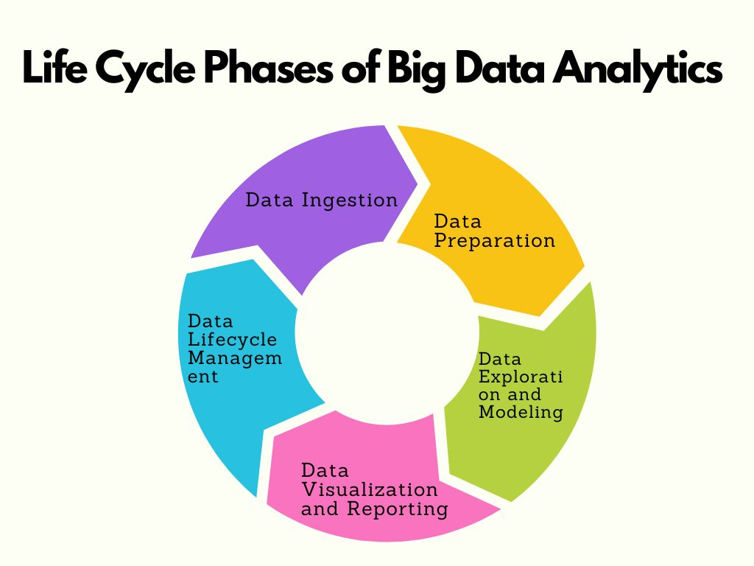

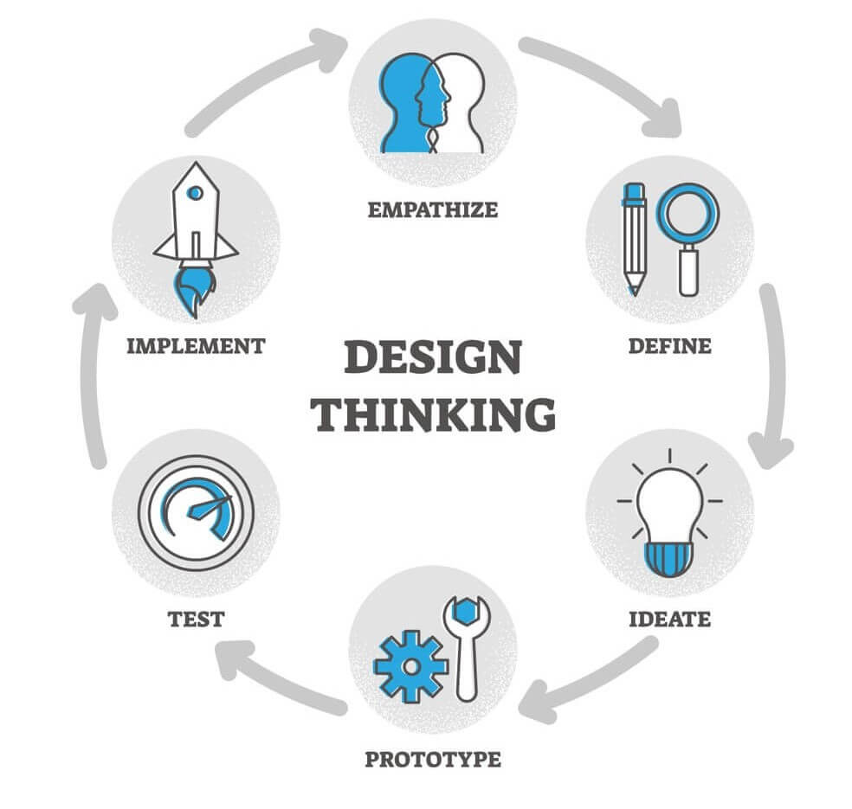

GitHub link

https://github.com/users/Thirisha4567/emails/283506531/confirm_verification/53967981?via_launch_code_email=true

program code1

from PIL import Image

import numpy as np

np.random.seed(0)

im = Image.open('image.jpeg', mode='r')

image = np.array(im)

H,W,C = image.shape

# create artificial labels from image color channels

label1 = image[:,:,0].astype(np.int32)//16

label2 = image[:,:,1].astype(np.int32)//16

depth = (image[:,:,2]+np.random.normal(size=(H,W))).astype(np.float32)

# write all data sample elements to file

with open('image.bin','wb') as f:

f.write(image.tobytes())

with open('label2.bin','wb') as f:

f.write(label2.tobytes())

with open('label1.bin','wb') as f:

f.write(label1.tobytes())

with open('depth.bin','wb') as f:

f.write(depth.tobytes())

program code 2

# Import necessary libraries

from pyspark import SparkContext

# Create a SparkContext

sc = SparkContext("local", "WordCount")

# Load a text file

text_file = sc.textFile("path_to_your_text_file.txt")

# Split each line into words

words = text_file.flatMap(lambda line: line.split(" "))

# Map each word to a key-value pair with 1 as the value

word_counts = words.map(lambda word: (word, 1))

# Reduce by key (word) and sum the values to get word counts

word_count = word_counts.reduceByKey(lambda a, b: a + b)

# Collect the results and print

results = word_count.collect()

for result in results:

print(result)

# Stop the SparkContext

sc.stop()

THANKYOU